

**Made By- SUMAN RAJAK**

**C PROGRAMMING CODES**

1. Even Digits Present in a number: -

#include<stdio.h>

int main()

{

int num,rem,digit;

printf("Enter an integer number: ");

scanf("%d",&num);

printf("\nThe Even digits present in %d are",num);

while(num>0)

{

digit = num % 10;

num = num / 10;

rem = digit % 2;

if(rem == 0)

printf("\n%d",digit);

}

return 0;

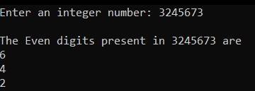

}

2. Grade Point Calculation: -

#include<stdio.h>

void main()

{

int p;

printf("Enter a Number\n");

scanf("%d",&p);

if (p>=90 && p<=100)

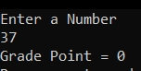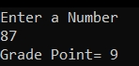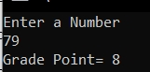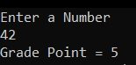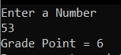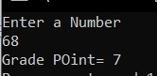 {

printf("Grade Point = 10");

}

else if (p>=80 && p<90)

{

printf ("Grade Point= 9");

}

else if (p>=70 && p<80)

{

printf("Grade Point= 8");

}

else if (p>=60 && p<70)

{

printf("Grade POint= 7");

}

else if (p>=50 && p<60)

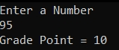 {

printf("Grade Point = 6");

}

else if (p>=40 && p<50)

{

printf("Grade Point = 5");

}

else if (p>=0 && p<40)

{

printf("Grade Point = 0");

}

return 0;

}

3.Factorial Calculating: -

#include <stdio.h>

#include<conio.h>

int main()

{

int n,i,f;

f=i=1;

printf("Enter a Number to Find Factorial: ");

scanf("%d",&n);

while(i<=n)

{

f=f*i;

i++;

}

printf("The Factorial of %d is : %d",n,f);

getch();

return 0;

}

4. Diwali 2020 Wish: -

#include<stdio.h>

#include<conio.h>

void main()

{

int date;

printf("Enter the Date\n");

scanf("%d",&date);

if (date==14)

{

printf("HAPPY CHILDREN'S DAY ");

printf("\nHAPPY DIWALI");

printf("\n SAFE DIWALI");

printf("\n UNLOCK HAPPINESS ");

}

else if (date<14)

printf("ADVANCE HAPPY DIWALI AND ADVANCE HAPPY CHILDREN'S DAY");

else if(date>14)

printf("WAITING FOR NEXT YEAR");

getch();

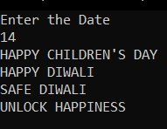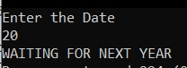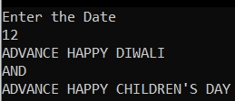}

5. Fibonacci Series: -

#include<stdio.h>

#include<conio.h>

void

main()

{

int i=0,j=1,k,a,n;

printf("Enter the number of terms\n");

scanf("%d",&n);

printf(" The Fibonacci Series is:\n ");

printf("%d%d",i,j);

for(a=3;a<=n;a++)

{

k=i+j;

i=j;

j=k;

printf("%d",k);

}

getch();

}

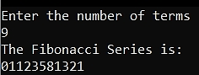

6. Largest Among Three Numbers: -

#include<stdio.h>

int main()

{

int a,b,c;

printf ("Enter Three Numbers\n");

scanf("%d %d %d",&a,&b,&c);

if (a>b && a>c)

printf("%d is the largest number",a);

else if (b>c && b>a)

printf("%d is the largest number",b);

else

printf("%d is the largest number",c);

}

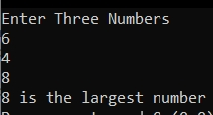

7. To Print this Pyramid: - 1

1 2

1 2 3…

#include<stdio.h>

void main()

{

int i,j,n;

printf("How many times do you want to print?\n");

scanf("%d",&n);

printf("\n");

for(i=1; i<=n; i++)

{

for (j=1; j<=i; j++)

printf("%d",j);

printf("\n");

}

return 0;

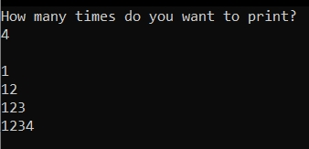}

8. To Print this Pyramid: - 1

2 2

3 3 3…

#include<stdio.h>

void main()

{

int i,j,n;

printf("How many times do you want to print?\n");

scanf("%d",&n);

printf("\n");

for(i=1; i<=n; i++)

{

for (j=1; j<=i; j++)

printf("%d",i);

printf("\n");

}

return 0;

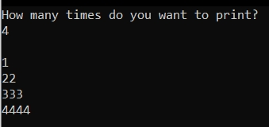}

9. To Print this Pyramid: - 1

1 1

1 1 1…

#include<stdio.h>

void main()

{

int i,j,n;

printf("How many times do you want to print?\n");

scanf("%d",&n);

printf("\n");

for(i=1; i<=n; i++)

{

for (j=1; j<=i; j++)

printf("1 ");

printf("\n");

}

return 0;

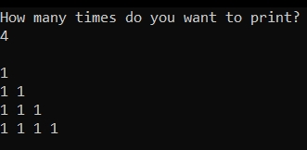}

10. To Print this Pyramid: - *

* *

* * *…

#include<stdio.h>

void main()

{

int i,j,n;

printf("How many times do you want to print?\n");

scanf("%d",&n);

printf("\n");

for(i=1; i<=n; i++)

{

for (j=1; j<=i; j++)

printf("* ");

printf("\n");

}

return 0;

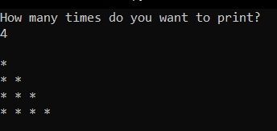}

11. To Print this Pyramid: - A

A B

A B C…

#include<stdio.h>

void main()

{

int i,j,n;

char ch='A';

printf("How many times do you want to print?\n");

scanf("%d",&n);

printf("\n");

for(i=1; i<=n; i++)

{

for (j=1; j<=i; j++)

{

printf("%c",ch);

ch++;

}

ch='A';

printf("\n");

}

return 0;

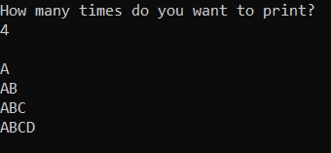}

12. To Print this Pyramid: - A

B C

D E F…

#include<stdio.h>

void main()

{

int i,j,n;

char ch='A';

printf("How many times do you want to print?\n");

scanf("%d",&n);

printf("\n");

for(i=1; i<=n; i++)

{

for (j=1; j<=i; j++)

{

printf("%c",ch);

ch++;

}

printf("\n");

}

return 0;

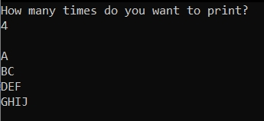}

13. To Print this Pyramid: - 1

2 3

4 5 6…

#include<stdio.h>

void main()

{

int i,j,n,k;

printf("How many times do you want to print?\n");

scanf("%d",&n);

printf("\n");

for(i=1; i<=n; i++)

{

for (j=1; j<=i; j++)

{

k++;

printf("%d",k);

}

printf("\n");

}

return 0;

}

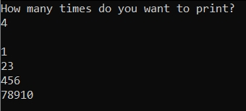

14. To Print this Pyramid: - 5 5 5 5 5

4 4 4 4

3 3 3

2 2

1

#include<stdio.h>

void main()

{

int i,j;

for(i=5; i>=1; i--)

{

for (j=1; j<=i; j++)

printf("%d ",i);

printf("\n");

}

}

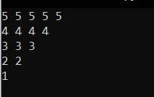

14. To Print this Pyramid: - * * * * *

* * * *

* * *

* *

*

#include<stdio.h>

void main()

{

int i,j;

for(i=1; i<=5; i++)

{

for (j=5; j>=i; j--)

printf(" * ");

printf("\n");

}

}

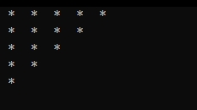

14. To Print this Pyramid: - *

* *

* * *

* * * *

………..

#include<stdio.h>

void main()

{

int i,j,k,n;

printf("Enter the number of lines\n");

scanf("%d",&n);

printf("\n");

for(i=1; i<=n; i++)

{

for (k=n; k>=i; k--)

printf(" ");

for (j=1; j<=i; j++)

printf("* ");

printf("\n");

}

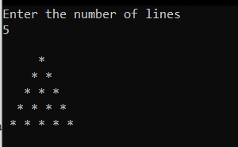}15. To Print these Pyramids (using switch case): -

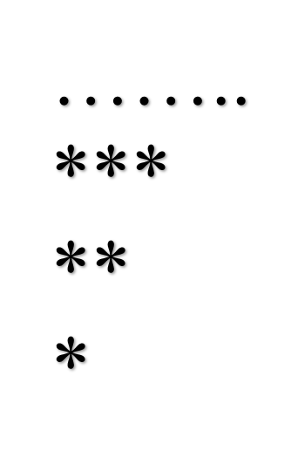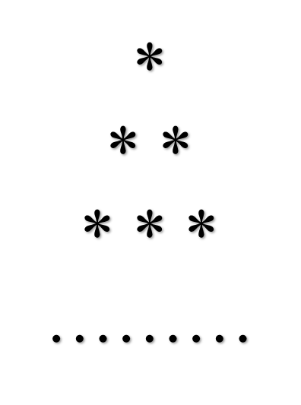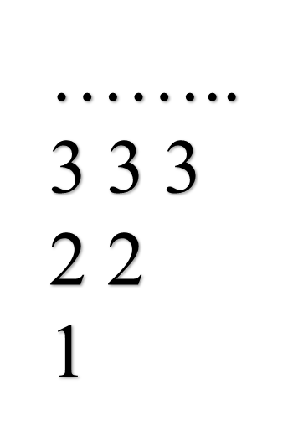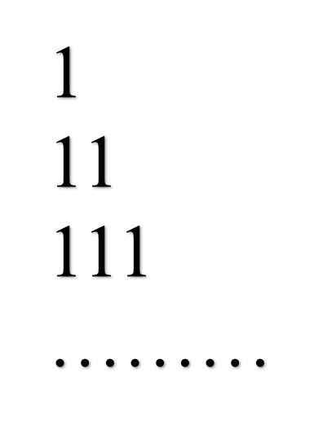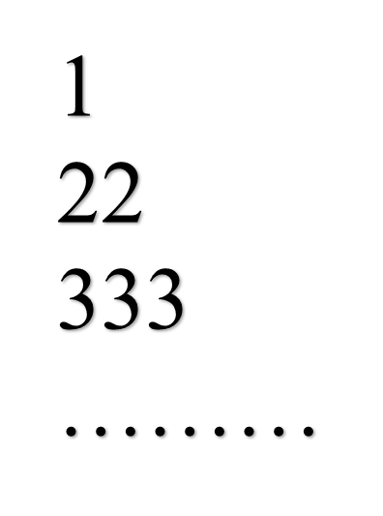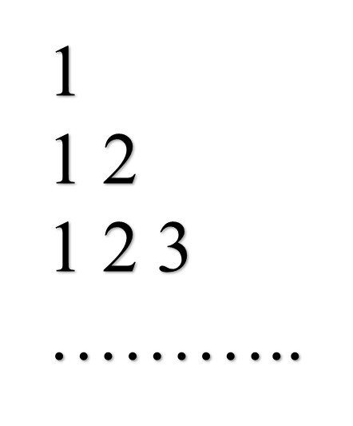

#include<stdio.h>

#include<conio.h>

int main()

{

int option;

printf("Enter your option\n");

scanf("%d",&option);

switch(option)

{

case 1:

{

int i,j,k,n;

printf("How many times do you want to print?\n");

scanf("%d",&n);

printf("\n");

for(i=1; i<=n; i++)

{

for (k=n; k>=i; k--)

printf(" ");

for (j=1; j<=i; j++)

printf("* ");

printf("\n");

}

break;

}

case 2:

{

int i,j,n;

printf("How many times do you want to print?\n");

scanf("%d",&n);

printf("\n");

for(i=1; i<=n; i++)

{

for (j=1; j<=i; j++)

printf("%d",j);

printf("\n");

}

break;

}

case 3:

{

int i,j,n;

printf("How many times do you want to print?\n");

scanf("%d",&n);

printf("\n");

for(i=1; i<=n; i++)

{

for (j=1; j<=i; j++)

printf("%d",i);

printf("\n");

}

break;

}

case 4:

{

int i,j,n;

printf("How many times do you want to print?\n");

scanf("%d",&n);

printf("\n");

for(i=1; i<=n; i++)

{

for (j=1; j<=i; j++)

printf("1 ");

printf("\n");

}

break;

}

case 5:

{

int i,j,n;

printf("How many times do you want to print?\n");

scanf("%d",&n);

printf("\n");

for(i=n; i>=1; i--)

{

for (j=1; j<=i; j++)

printf("%d ",i);

printf("\n");

}

break;

}

case 6:

{

int i,j,n;

printf("How many times do you want to print?\n");

scanf("%d",&n);

printf("\n");

for(i=n; i>=1; i--)

{

for (j=1; j<=i; j++)

printf("*");

printf("\n");

}

break;

default:

printf("Please Enter a value between 1 to 6");

}

return 0;

}

getch();

}